**Robin Polack Bio**

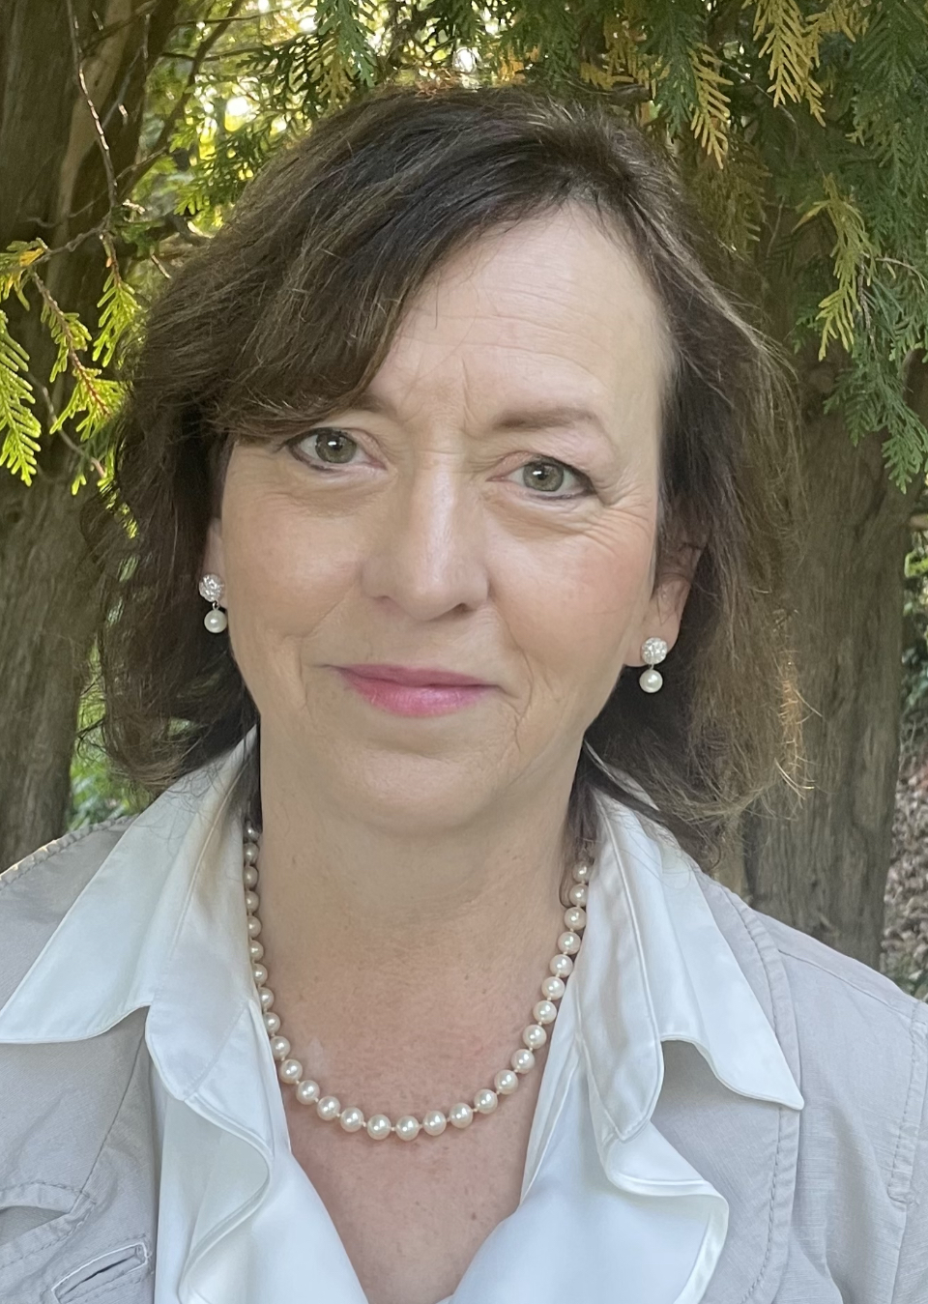

Robin Polack joined Zero Abuse Project in October 2023 as Director of Finance and Administration. She brings over 20 years of experience in the operations management field. She was previously employed with a non-profit seeking to improve the lives of those most in need with special attention to families, women, and children living in poverty. In this role, she was responsible for financial oversight and general operations of a $4.5 million budget across multiple program areas.

With many years of volunteering, Robin’s passion has been to help women and children. Her volunteer commitments have included serving as a personal finance and economic instructor for youth with Junior Achievement, serving as a children’s and family coordinator with the Salvation Army and working in multiple roles within the local school district and faith community where she resides.

In addition to an undergraduate degree in Business Administration from Cleveland State University, Robin holds an Executive MBA from the Weatherhead School of Management at Case Western Reserve University.